Digital Lock System (4-Bit Combination)

a 4-bit digital lock that compares a user-entered 4-bit code (entered through DIP switches or push buttons) to a stored combination given. If the user input matches the stored combination, an output LED labelled “Unlocked” should light up; otherwise, it stays off.

i)D Latch:

A **D latch** is a logic circuit that holds and stores a single bit of data. It has two primary inputs:

1. **D (Data)** - Input signal to be stored.
2. **E (Enable)** - Controls when the latch updates its output.

Working :D Latch stores the data that is present in the data pin to the output pin when the store pin goes from 0 (low) to 1(high)

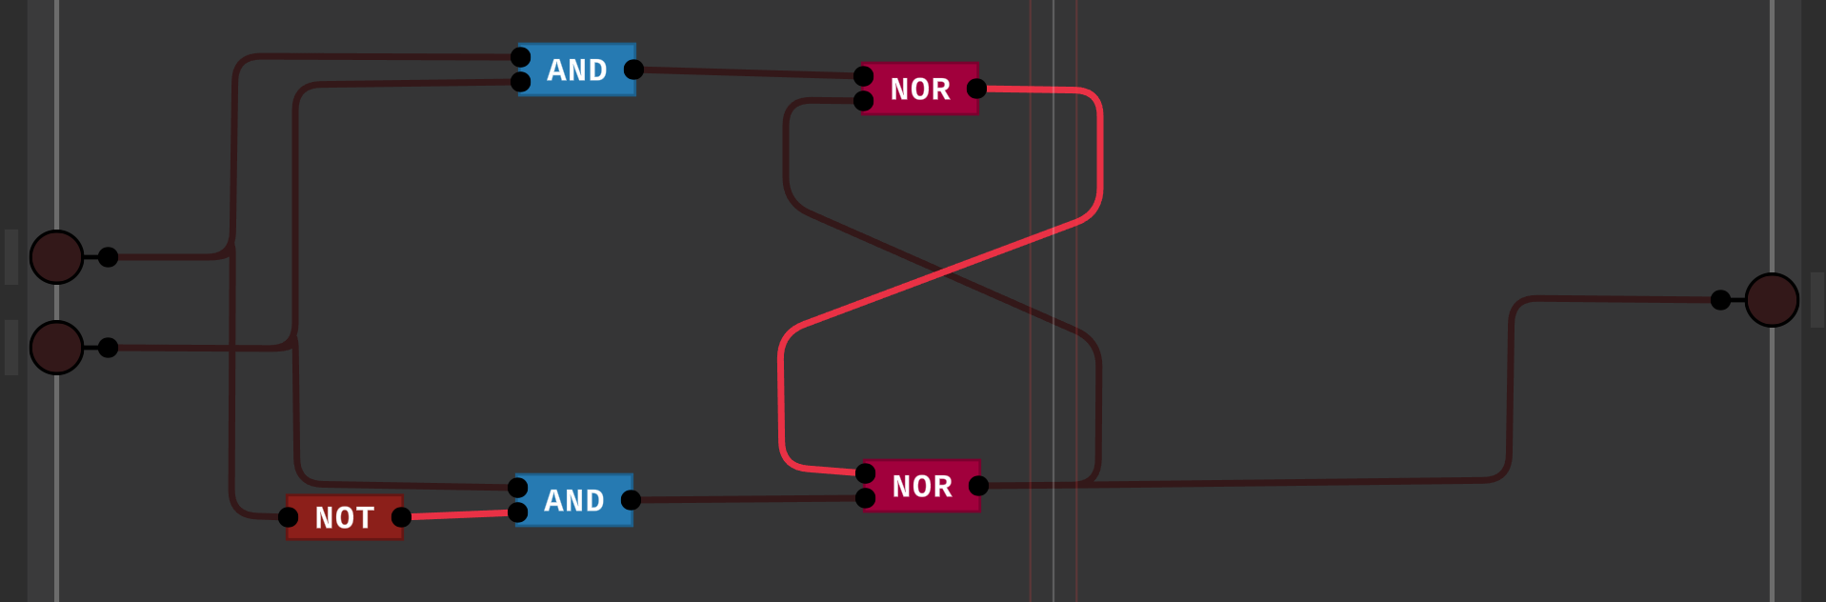

If E is off, the data pin will not affect the output pin; if E is on, any data present in the data pin will be stored in the output pin.

This is a built-in Multisim.

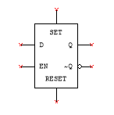

ii)D Flip Flop:

A **D flip-flop** is a sequential logic circuit that stores one bit of data and operates on clock edges (rising or falling). It has two primary inputs:

1. **D (Data)** - Input signal to be stored.
2. **CLK (Clock)** - Synchronizes the operation.

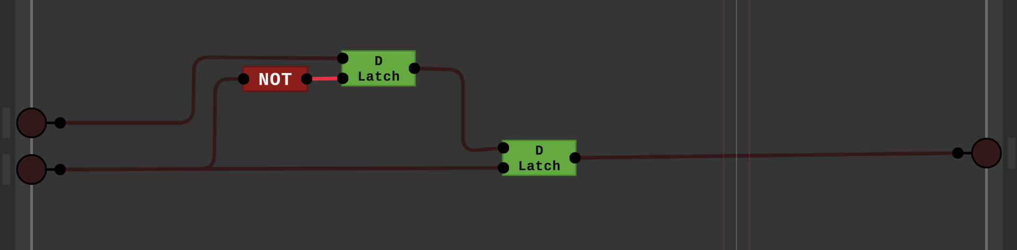

D flip flop function is similar to that D latch, it stores data present in the data pin to the output pin only when the clock pin goes from low(0) to high (1) [in this design]

This is found in built-in multisite.

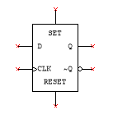

iii)XOR:

 The XOR gate can take only two inputs at a time and give an output. Its output is high(1) only when its two inputs are dissimilar, i.e., if one of them is low(0), then the other one will be high(1).

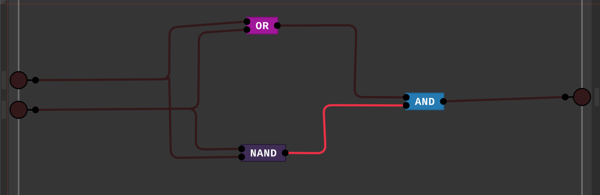

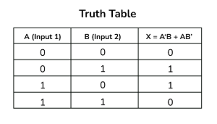 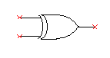

III)Digital lock system:

The working of this is explained in the video

